Forecasting Energy Consumption via LSTM

1. Topic - This project aims to predict the electricity load consumption viausing LSTM recurrent neural network
2. Dataset – I found two datasets to build different models via LSTM to predict load consumption
3. Yearly prediction – by using Brazil energy consumption from Kaggle

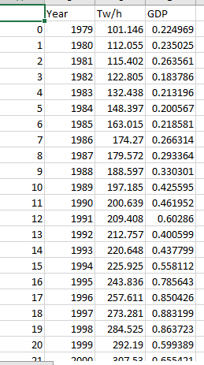

1. Hourly energy consumption based on the load of previous 23 hours using LSTM RNN

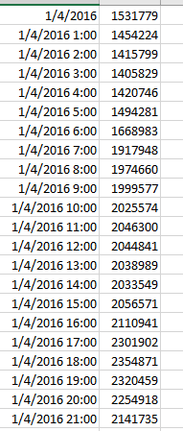

1. Proposal - I would like to use the deep learning RNN to build LSTM model to see if predicting energy load based on the data I found is possible and at what accuracy. I would like to try to build two models – one is yearly and another one is hourly